Adadelta (instead of Adam)

First run (970 train, 108 validate) :  
(forgot to note down more information)

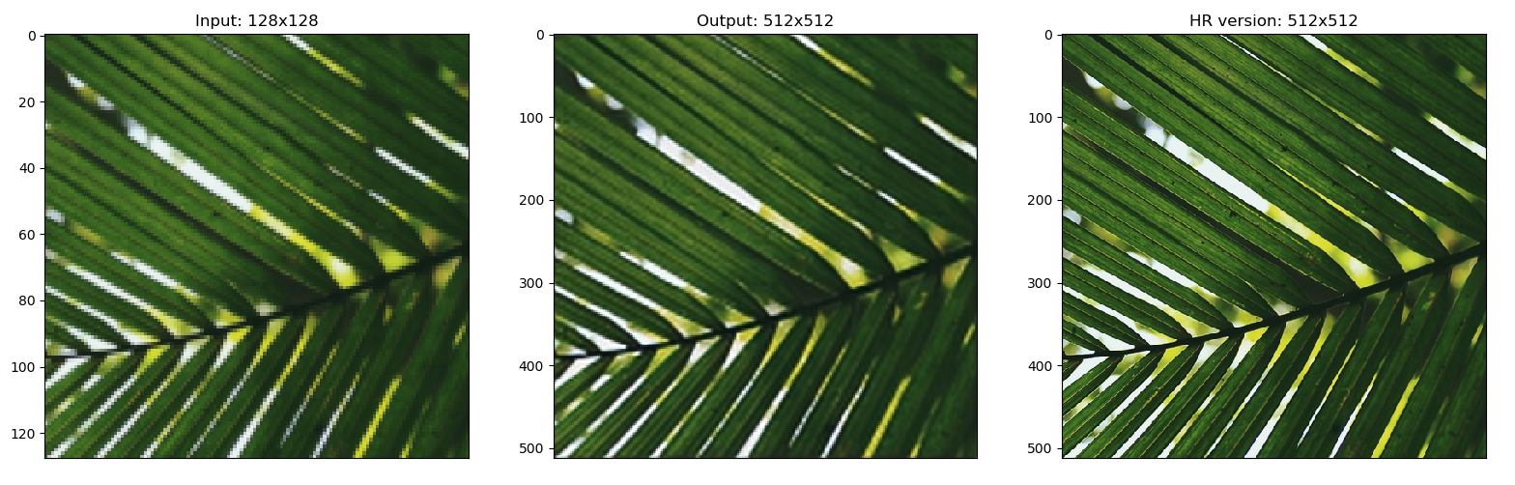

Train on 982 samples, validate on 110 samples

Epoch 1/6

- 1451s - loss: 0.0051 - val_loss: 0.0041

Epoch 2/6

- 1429s - loss: 0.0049 - val_loss: 0.0038

Epoch 3/6

- 1429s - loss: 0.0047 - val_loss: 0.0038

Epoch 4/6

- 1430s - loss: 0.0045 - val_loss: 0.0038

Epoch 5/6

- 1446s - loss: 0.0044 - val_loss: 0.0037

Epoch 6/6

- 1439s - loss: 0.0044 - val_loss: 0.0037

[evaluate] Test loss: 0.006485841030635956

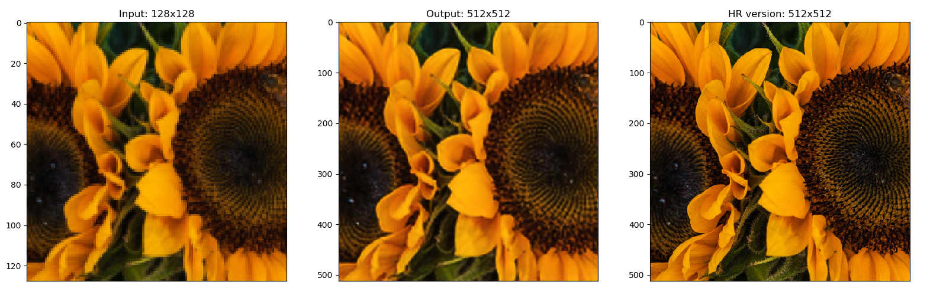

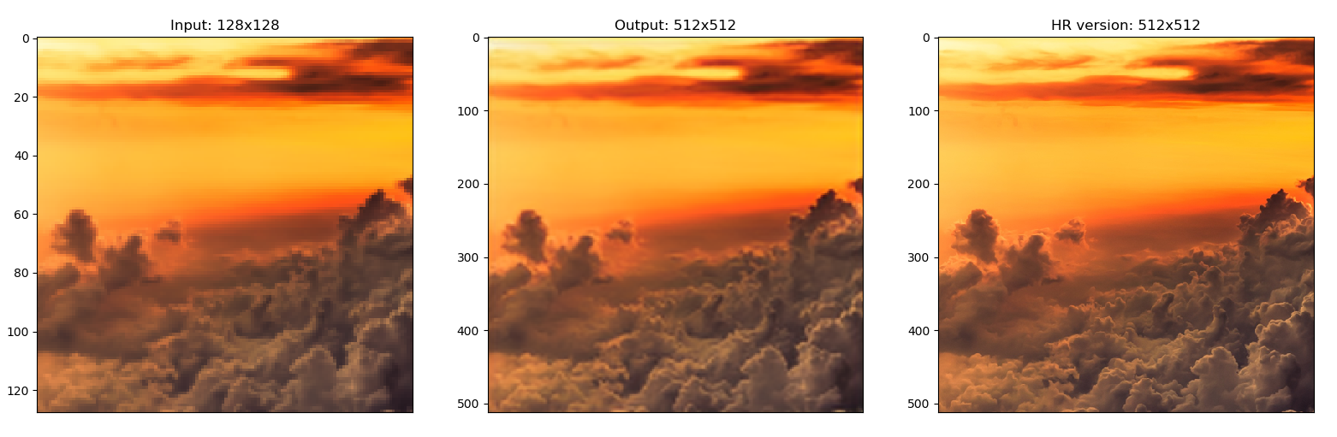

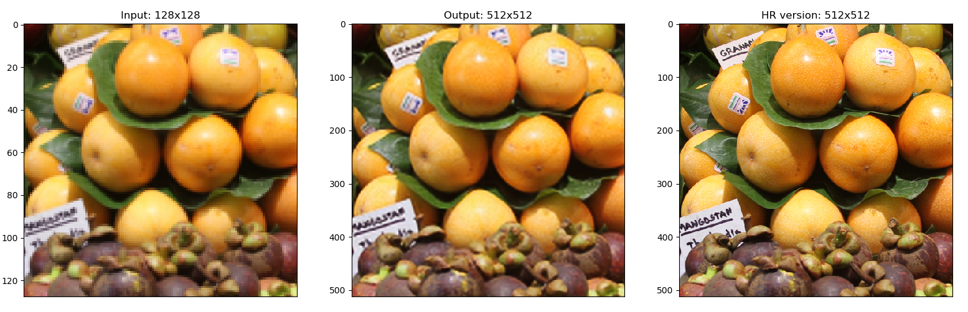

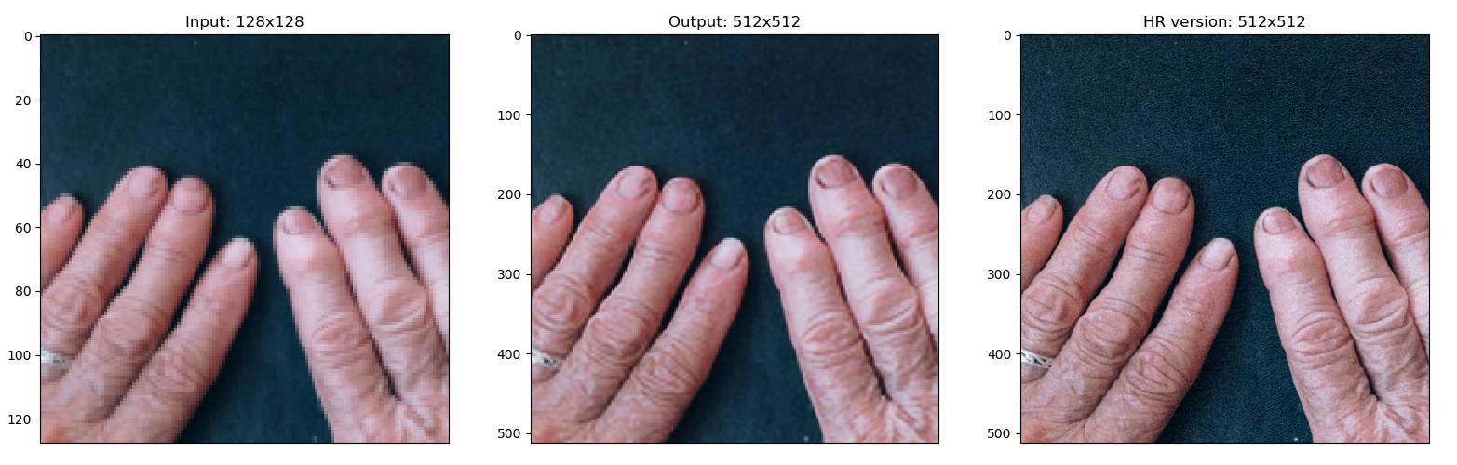

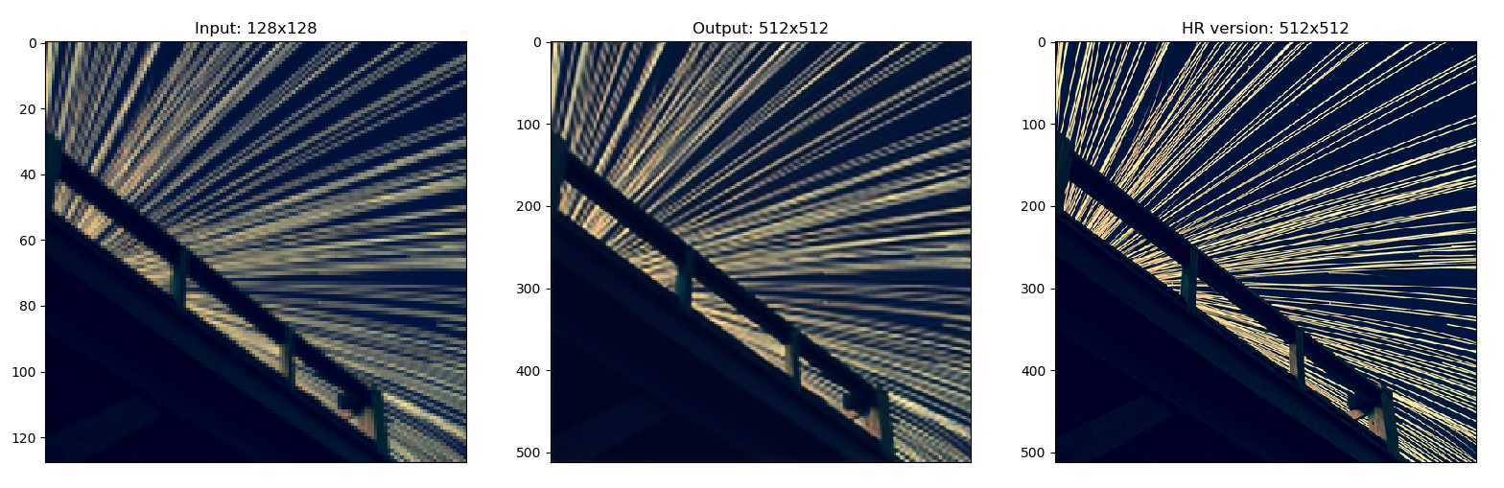

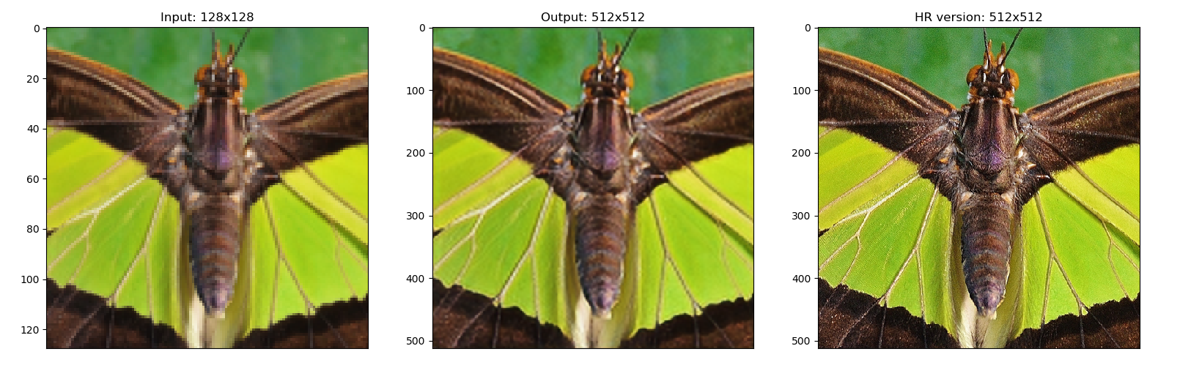

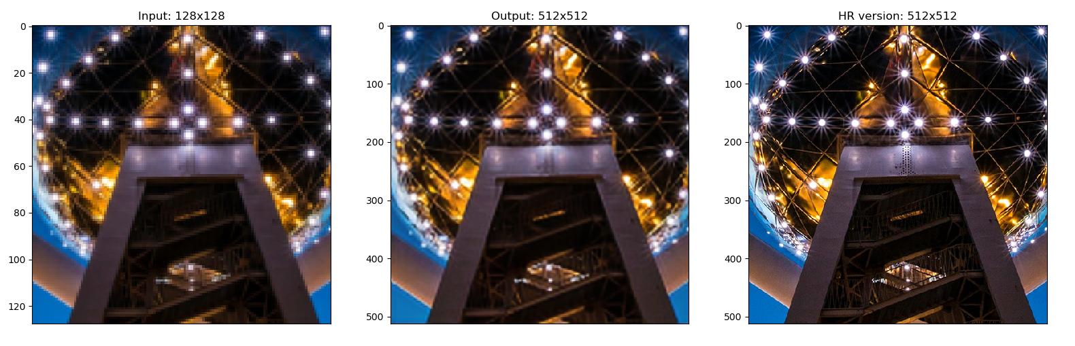

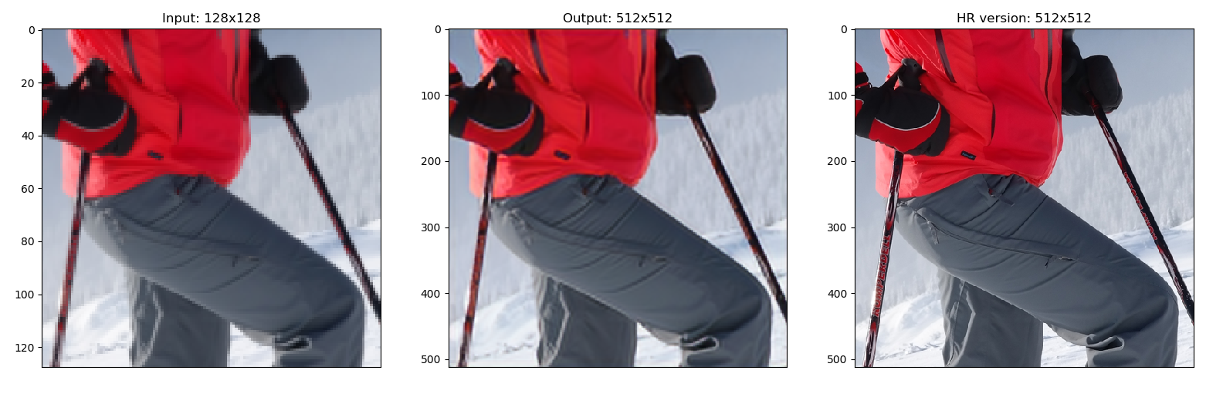

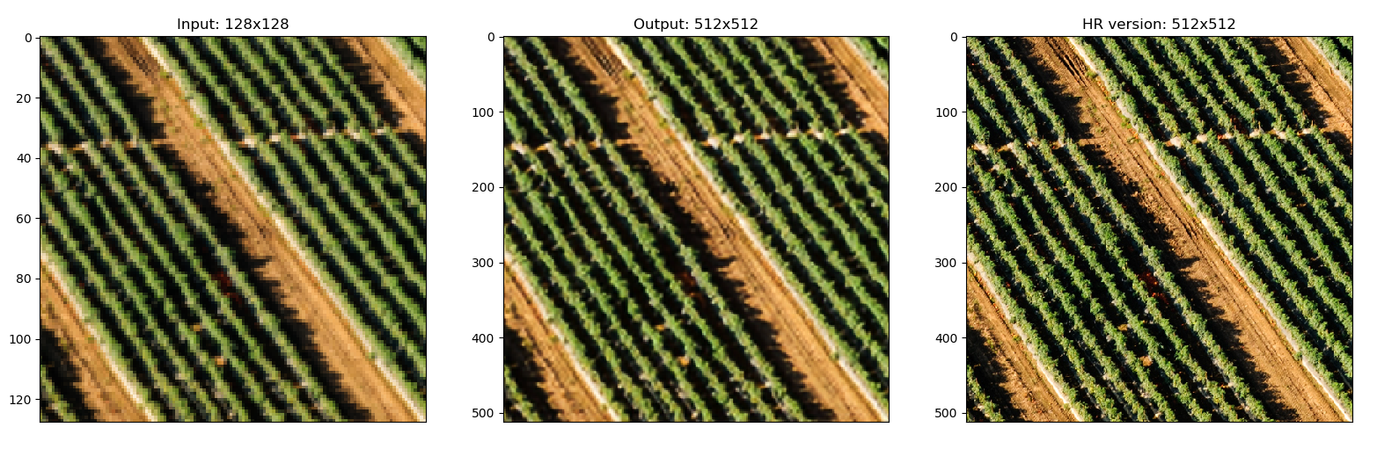

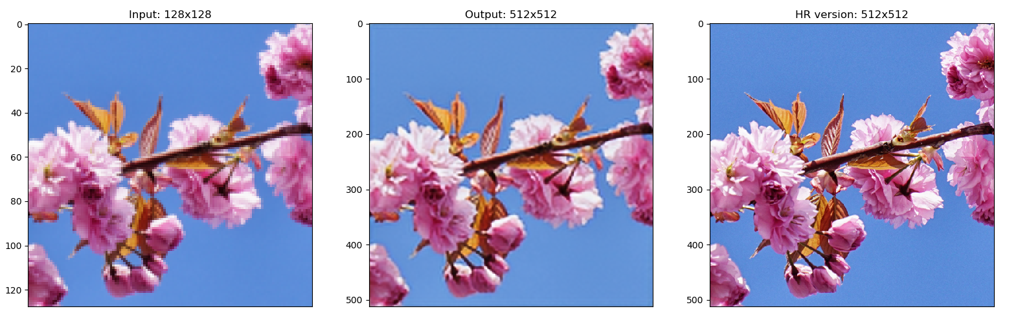

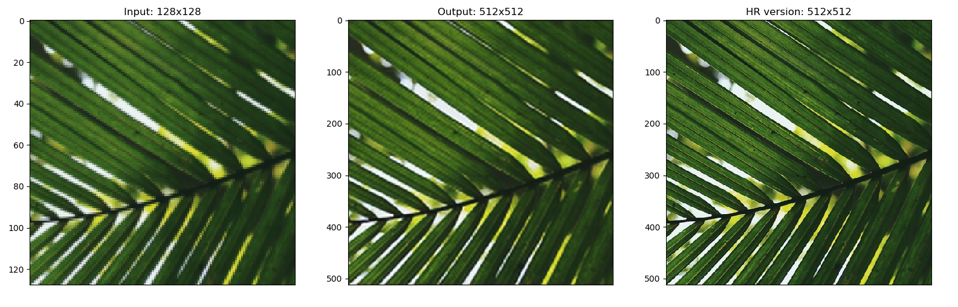

Train on 977 samples, validate on 109 samples

Epoch 1/6

- 1445s - loss: 0.0049 - val_loss: 0.0048

Epoch 2/6

- 1426s - loss: 0.0047 - val_loss: 0.0060

Epoch 3/6

- 1427s - loss: 0.0044 - val_loss: 0.0041

Epoch 4/6

- 1426s - loss: 0.0043 - val_loss: 0.0042

Epoch 5/6

- 1423s - loss: 0.0042 - val_loss: 0.0040

Epoch 6/6

- 1419s - loss: 0.0042 - val_loss: 0.0041

[evaluate] Test loss: 0.006752510930792513

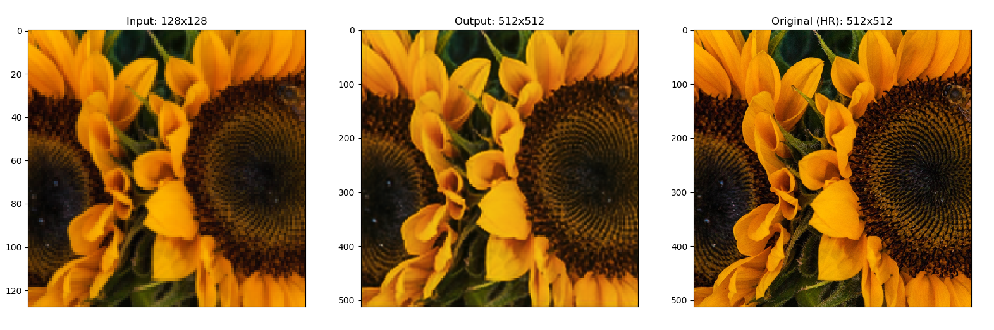

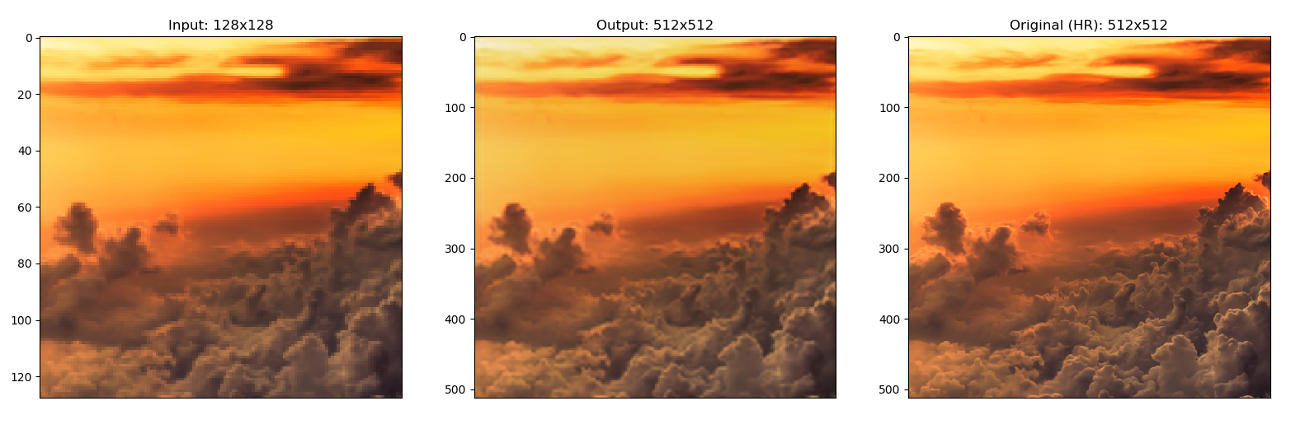

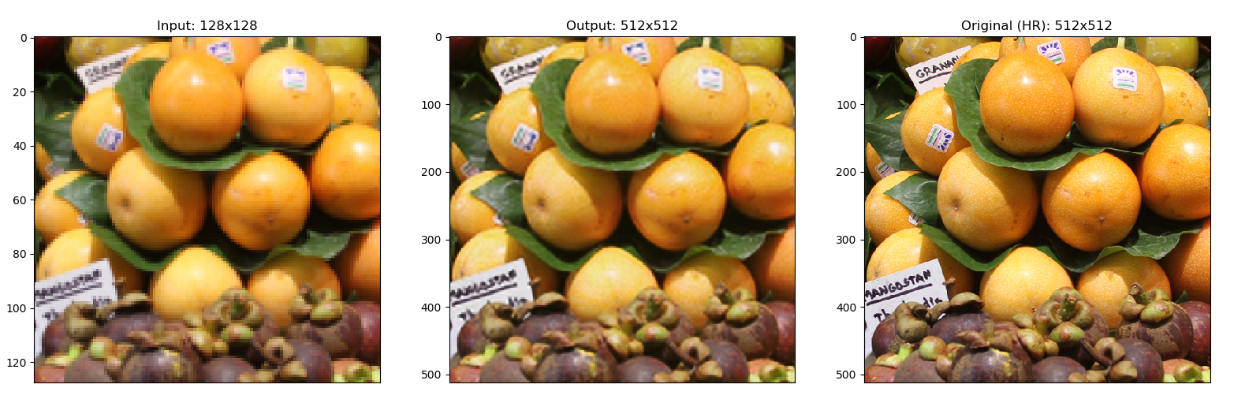

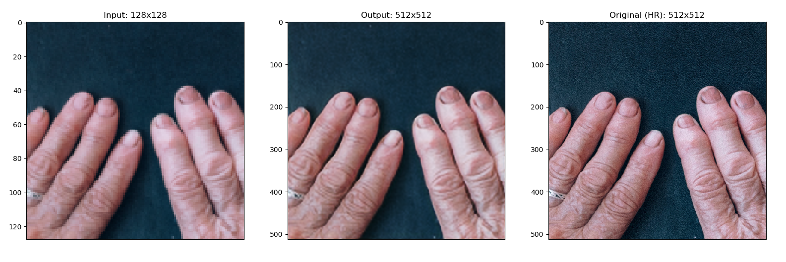

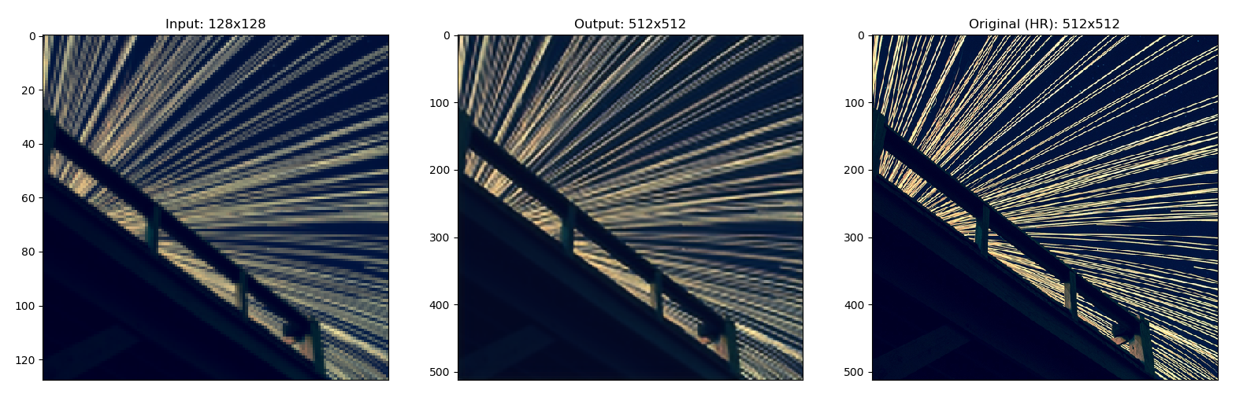

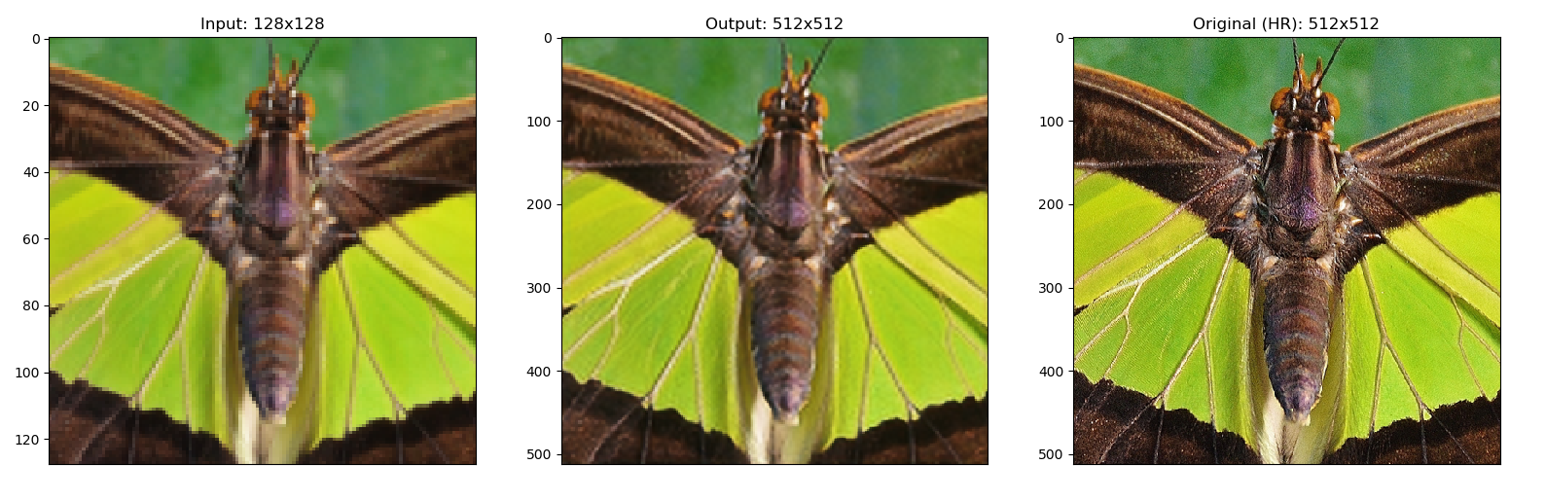

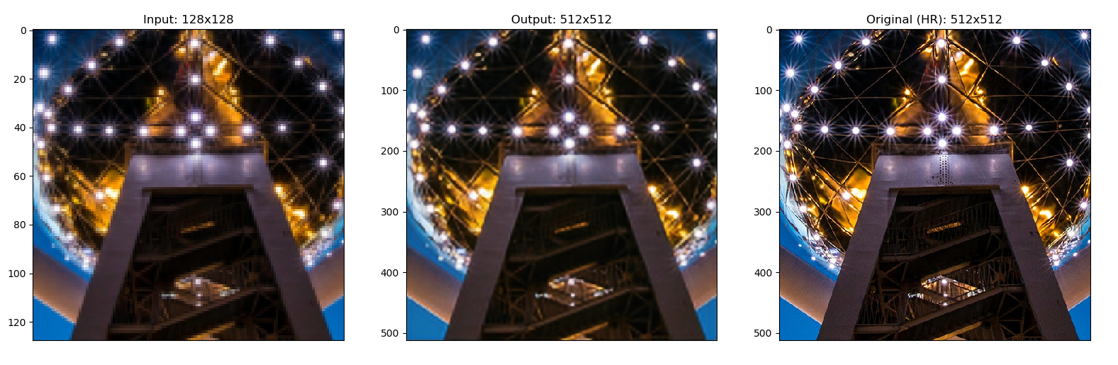

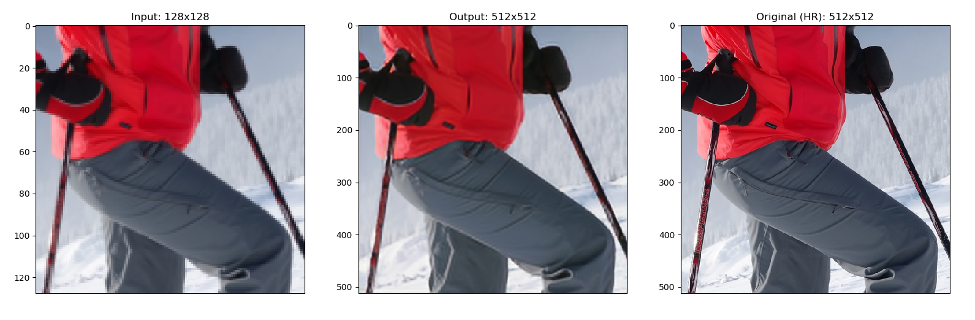

CRASHED…